To implement the proposed solution for the system design phase, the following steps were considered.

* Centralized system: For the ticketing management system, we are designing to host all the components in a single network location. This is due to the following reasons.
* Easy to maintain
* Single point of failure
* Less expensive
* Limited number of users

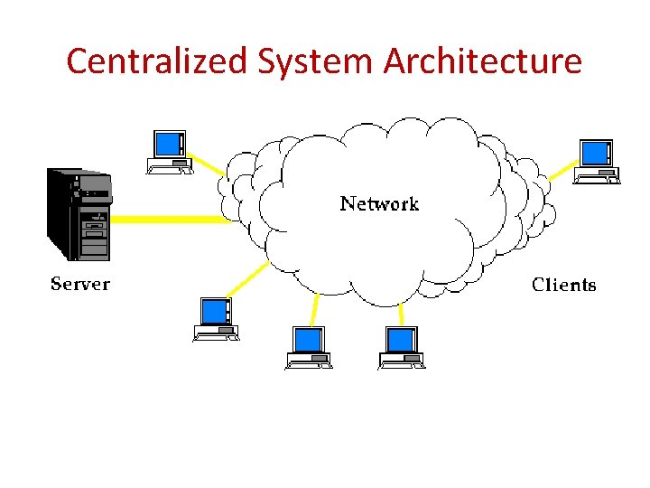

* Thin Client: For the ticketing management system, the application portal interface would be accessed via the web browser. The complete processing is carried out on the server.  In addition,thin client apps can be accessed by any computer or mobile device that has internet access.

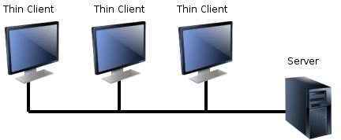

* Two-Tier Architecture: we are designing to split the components into two different hardware. Where the presentation or interface run on the client side while the application logic and data layer runs on the server side.

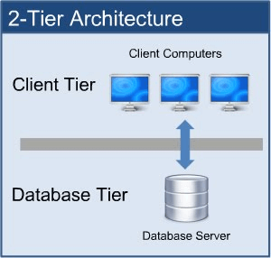

Test Plan

|  |  |  |  |
| --- | --- | --- | --- |
| Test Type | Step | Test Case | Automated/Manual |
| Functional | 1  2  3  4  5  6 | -All Clients can logins to the web portal  -SPOC permission test to read write and close the ticket  - Client can create and read the ticket  - Field Team can read and update the ticket  - Ensure the display of ticket status (Open -> Assigned -> Close)  - Ensure the Clients are receiving the notification via web portal | Automated  Manual  Manual  Manual  Automated  Automated |
| Performance | 1  2 | Response Time  Network | Manual  Manual |
| Security | 1  2 | Authentication  Authorization | Automated  Automated |